**PRE-K 4 SUPPLY LIST**

**HENRY J. KALFAS ELEMENTARY SCHOOL**

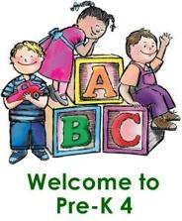

**2 BOXES OF CRAYONS**

**3 GLUE STICKS**

**1 BOX OF TISSUE**

**1 BOTTLE OF HAND SANITIZER**

**1 BOX OF SANDWICH ZIP-LOCK BAGGIES**

**1 BLANKET FOR REST**

**CHANGE OF CLOTHES (SHIRT, PANTS, UNDERWEAR, SOCKS AND PLEASE LABEL)**

**GIRLS: 1 PACKAGE OF BABY WIPES**

**BOYS: 1 CONTAINER OF Disinfectant WIPES**

**\*\*IN AN EFFORT TO KEEP EVERYONE’S BELONGS SEPARATED AND ORGANIZED, WE WOULD APPRECIATE IT IF YOU COULD PLEASE LABEL YOUR CHILD’S SUPPLIES WITH HIS OR HER NAME IN PERMANENT MARKER PRIOR TO THE 1ST DAY OF SCHOOL\*\***